**Software Engineering**

**Unit :- 1**

**Software Development Life Cycle (SDLC)**

Software Development Life Cycle (SDLC) is a process used by the software industry to design, develop and test high quality softwares. The SDLC aims to produce a high-quality software that meets or exceeds customer expectations, reaches completion within times and cost estimates.

* SDLC is the acronym of Software Development Life Cycle.
* It is also called as Software Development Process.
* SDLC is a framework defining tasks performed at each step in the software development process.
* ISO/IEC 12207 is an international standard for software life-cycle processes. It aims to be the standard that defines all the tasks required for developing and maintaining software.

**What is SDLC?**

SDLC is a process followed for a software project, within a software organization. It consists of a detailed plan describing how to develop, maintain, replace and alter or enhance specific software. The life cycle defines a methodology for improving the quality of software and the overall development process.

* The following figure is a graphical representation of the various stages of a typical SDLC.

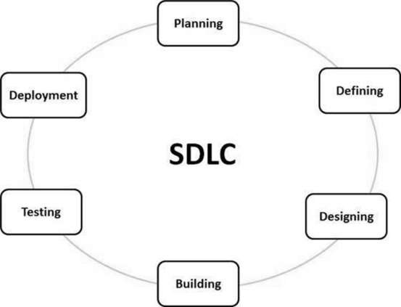

### A typical Software Development Life Cycle consists of the following stages –

### **Stage 1: Planning and Requirement Analysis**

Requirement analysis is the most important and fundamental stage in SDLC. It is performed by the senior members of the team with inputs from the customer, the sales department, market surveys and domain experts in the industry. This information is then used to plan the basic project approach and to conduct product feasibility study in the economical, operational and technical areas.

### **Stage 2: Defining Requirements**

Once the requirement analysis is done the next step is to clearly define and document the product requirements and get them approved from the customer or the market analysts. This is done through an **SRS (Software Requirement Specification)** document which consists of all the product requirements to be designed and developed during the project life cycle.

### **Stage 3: Designing the Product Architecture**

SRS is the reference for product architects to come out with the best architecture for the product to be developed. Based on the requirements specified in SRS, usually more than one design approach for the product architecture is proposed and documented in a DDS - Design Document Specification.

This DDS is reviewed by all the important stakeholders and based on various parameters as risk assessment, product robustness, design modularity, budget and time constraints, the best design approach is selected for the product.

A design approach clearly defines all the architectural modules of the product along with its communication and data flow representation with the external and third party modules (if any). The internal design of all the modules of the proposed architecture should be clearly defined with the minutest of the details in DDS.

### **Stage 4: Building or Developing the Product**

In this stage of SDLC the actual development starts and the product is built. The programming code is generated as per DDS during this stage. If the design is performed in a detailed and organized manner, code generation can be accomplished without much hassle.

Developers must follow the coding guidelines defined by their organization and programming tools like compilers, interpreters, debuggers, etc. are used to generate the code. Different high level programming languages such as C, C++, Pascal, Java and PHP are used for coding. The programming language is chosen with respect to the type of software being developed.

### **Stage 5: Testing the Product**

This stage is usually a subset of all the stages as in the modern SDLC models, the testing activities are mostly involved in all the stages of SDLC. However, this stage refers to the testing only stage of the product where product defects are reported, tracked, fixed and retested, until the product reaches the quality standards defined in the SRS.

### **Stage 6: Deployment in the Market and Maintenance**

Once the product is tested and ready to be deployed it is released formally in the appropriate market. Sometimes product deployment happens in stages as per the business strategy of that organization. The product may first be released in a limited segment and tested in the real business environment (UAT- User acceptance testing).

Then based on the feedback, the product may be released as it is or with suggested enhancements in the targeting market segment. After the product is released in the market, its maintenance is done for the existing customer base.

**SDLC Models**

There are various software development life cycle models defined and designed which are followed during the software development process. These models are also referred as Software Development Process Models". Each process model follows a Series of steps unique to its type to ensure success in the process of software development.

Following are the most important and popular SDLC models followed in the industry −

* Waterfall Model
* Iterative Model
* Spiral Model
* Prototyping Model
* Evolutionary Model
* **Waterfall Model**

Waterfall approach was first SDLC Model to be used widely in Software Engineering to ensure success of the project. In "The Waterfall" approach, the whole process of software development is divided into separate phases. In this Waterfall model, typically, the outcome of one phase acts as the input for the next phase sequentially.

The following illustration is a representation of the different phases of the Waterfall Model.

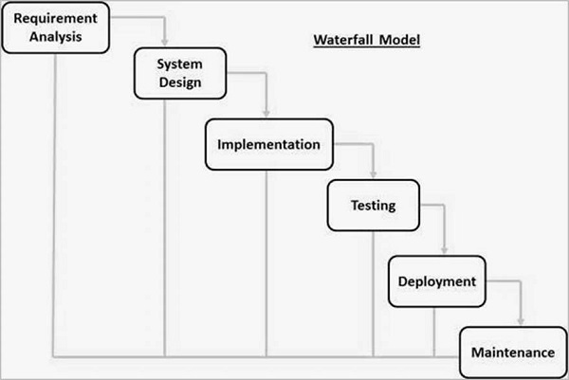

The sequential phases in Waterfall model are −

* **Requirement Gathering and analysis** − All possible requirements of the system to be developed are captured in this phase and documented in a requirement specification document.
* **System Design** − The requirement specifications from first phase are studied in this phase and the system design is prepared. This system design helps in specifying hardware and system requirements and helps in defining the overall system architecture.
* **Implementation** − With inputs from the system design, the system is first developed in small programs called units, which are integrated in the next phase. Each unit is developed and tested for its functionality, which is referred to as Unit Testing.
* **Integration and Testing** − All the units developed in the implementation phase are integrated into a system after testing of each unit. Post integration the entire system is tested for any faults and failures.
* **Deployment of system** − Once the functional and non-functional testing is done; the product is deployed in the customer environment or released into the market.
* **Maintenance** − There are some issues which come up in the client environment. To fix those issues, patches are released. Also to enhance the product some better versions are released. Maintenance is done to deliver these changes in the customer environment.

## Advantages :-

* Simple and easy to understand and use
* Phases are processed and completed one at a time.
* Clearly defined stages.
* Well understood milestones.
* Easy to arrange tasks.
* Process and results are well documented.
* It is best for small project.

## Disadvantages :-

* No working software is produced until late during the life cycle.
* High amounts of risk and uncertainty.
* Not a good model for complex and object-oriented projects.
* Poor model for long and ongoing projects.
* Not suitable for the projects where requirements are at a moderate to high risk of changing. So, risk and uncertainty is high with this process model.
* It is difficult to measure progress within stages.
* It is not well for large project.

## Iterative Model

Iterative Model is similar to Waterfall Model. Iterative process starts with a simple implementation of a subset of the software requirements and iteratively enhances the evolving versions until the full system is implemented. At each iteration, design modifications are made and new functional capabilities are added. The basic idea behind this method is to develop a system through repeated cycles (iterative) and in smaller portions at a time (incremental).

* **The following illustration is a representation of the Iterative and Incremental model −**

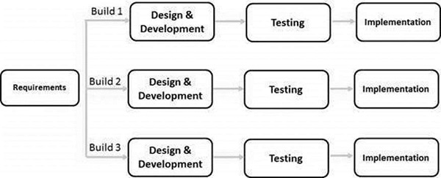

## Advantages :-

* Simple and easy to understand and use
* Phases are processed and completed one at a time.
* Clearly defined stages.
* Well understood milestones.
* Easy to arrange tasks.
* Process and results are well documented.
* It is best for small project.
* In iterative we can change the requirement during developing time.

## Disadvantages :-

* No working software is produced until late during the life cycle.
* High amounts of risk and uncertainty.
* Not a good model for complex and object-oriented projects.
* Poor model for long and ongoing projects.
* Not suitable for the projects where requirements are at a moderate to high risk of changing. So, risk and uncertainty is high with this process model.
* It is difficult to measure progress within stages.
* It is not well for large project.

## Spiral Model

The spiral model has four phases. A software project repeatedly passes through these phases in iterations called Spirals.

Spiral model use for large project. This model use by NASA and ISRO.

**Spiral model** is one of the most important Software Development Life Cycle models, which provides support for **Risk Handling**. In its diagrammatic representation, it looks like a spiral with many loops. The exact number of loops of the spiral is unknown and can vary from project to project. Each loop of the spiral is called a **Phase of the software development process.**

**The below diagram shows the different phases of the Spiral Model: –**

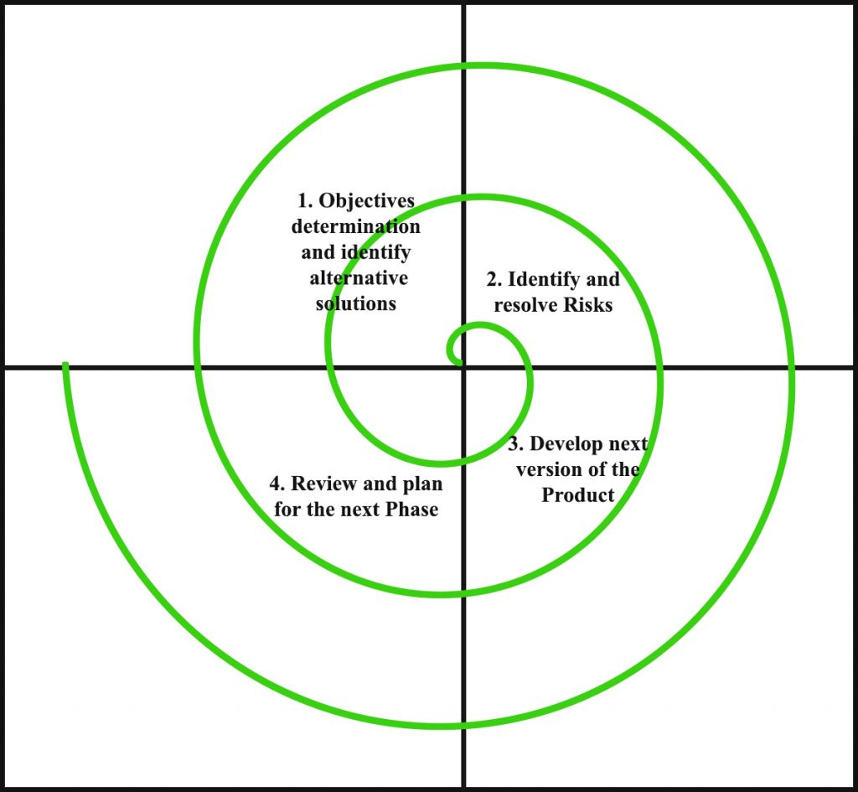

1. **Objectives determination and identify alternative solutions:** Requirements are gathered from the customers and the objectives are identified, elaborated, and analyzed at the start of every phase. Then alternative solutions possible for the phase are proposed in this quadrant.
2. **Identify and resolve Risks:** During the second quadrant, all the possible solutions are evaluated to select the best possible solution. Then the risks associated with that solution are identified and the risks are resolved using the best possible strategy. At the end of this quadrant, the Prototype is built for the best possible solution.
3. **Develop next version of the Product:** During the third quadrant, the identified features are developed and verified through testing. At the end of the third quadrant, the next version of the software is available.
4. **Review and plan for the next Phase:** In the fourth quadrant, the Customers evaluate the so far developed version of the software. In the end, planning for the next phase is started.

* **Advantages:-**

1. **Risk Handling:** The projects with many unknown risks that occur as the development proceeds, in that case, Spiral Model is the best development model to follow due to the risk analysis and risk handling at every phase.
2. **Good for large projects:** It is recommended to use the Spiral Model in large and complex projects.
3. **Flexibility in Requirements:** Change requests in the Requirements at later phase can be incorporated accurately by using this model.

* **Disadvantages :-**
* **Complex:** The Spiral Model is much more complex than other SDLC models.
* **Expensive:** Spiral Model is not suitable for small projects as it is expensive.
* **Too much dependability on Risk Analysis:** The successful completion of the project is very much dependent on Risk Analysis. Without very highly experienced experts, it is going to be a failure to develop a project using this model.

# **Prototype Model**

Prototype Model is part of SDLC . It is smallest model .This model is use to create small Design of software by developer to show customers. **Prototyping Model** is a software development model in which prototype is built, tested, and reworked until an acceptable prototype is achieved. It also creates base to produce the final system or software. It works best in scenarios where the project’s requirements are not known in detail. It is an iterative, trial and error method which takes place between developer and client.

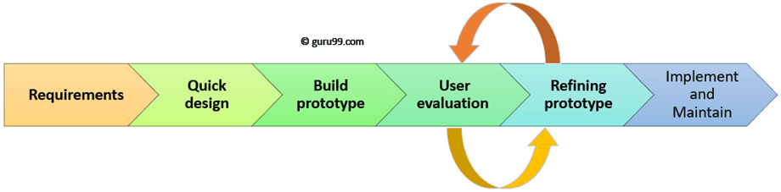

Prototyping Model has following six SDLC phases as follow:

### Step 1: Requirements gathering and analysis

A prototyping model starts with requirement analysis. In this phase, the requirements of the system are defined in detail. During the process, the users of the system are interviewed to know what is their expectation from the system.

### Step 2: Quick design

The second phase is a preliminary design or a quick design. In this stage, a simple design of the system is created. However, it is not a complete design. It gives a brief idea of the system to the user. The quick design helps in developing the prototype.

### Step 3: Build a Prototype

In this phase, an actual prototype is designed based on the information gathered from quick design. It is a small working model of the required system.

### Step 4: Initial user evaluation

In this stage, the proposed system is presented to the client for an initial evaluation. It helps to find out the strength and weakness of the working model. Comment and suggestion are collected from the customer and provided to the developer.

### Step 5: Refining prototype

If the user is not happy with the current prototype, you need to refine the prototype according to the user’s feedback and suggestions.

This phase will not over until all the requirements specified by the user are met. Once the user is satisfied with the developed prototype, a final system is developed based on the approved final prototype.

### Step 6: Implement Product and Maintain

Once the final system is developed based on the final prototype, it is thoroughly tested and deployed to production. The system undergoes routine maintenance for minimizing downtime and prevent large-scale failures.

# **Evolutionary model**

The evolutionary model is the model of software engineering. In the evolutionary model, **all the work is done during the development** **phase.** In this model, **all work divided into small chunks or modules.** For example, the [Waterfall model](https://t4tutorials.com/waterfall-model-advantages-disadvantages-and-examplesin-software-engineering/) in which all the users are able to get access to the product at the end of each cycle. This model is a **combination of**[incremental](https://t4tutorials.com/incremental-model-in-software-engineering-advantages-disadvantages-examples-case-study-of-incremental-model/)**and**[iterative](https://t4tutorials.com/what-is-iterative-model-software-engineering/)**models.**

It is a very suitable model because of **user feedback** and other factors that make the model very suitable for the development of complete Software. The user feedback is very helpful for the development of the next stage because after the completion of one stage we get the feedback to the user, the user feedback is very essential for the development of the next phase.

If you want any changes in the [software requirements](https://t4tutorials.com/srs-software-requirement-specification/), all changes will be applied within a time.

* **Advantages of Evolutionary Model :-**

There are many advantages of evolutionary model, Some main advantages are mentioned below;

1. The big advantage of the evolutionary model is that t**he user has checked every stage** during the development and it is helpful in achieving customer confidence.
2. There are fewer chances of errors because all the modules are well seen.
3. It helps to**reduce the risk** of software projects.
4. It also **reduces the cost of development**.
5. **Minimize serious problems during**[testing](https://t4tutorials.com/software-testing-tutorials/)**.**

**Disadvantages of  Evolutionary Model :-**

There are many dis-advantages of evolutionary model, Some main advantages are mentioned below;

1. The **delivery of full software can be late** due to different changes by customers during development.
2. It is **difficult to divide the problem into several parts**, that would be acceptable to the customer which can be incrementally implemented and delivered.

# **Feasibility Study**

**Feasibility Study :-** in [Software Engineering](https://www.geeksforgeeks.org/software-engineering-introduction-to-software-engineering/) is a study to evaluate feasibility of proposed project or system. Feasibility study is one of stage among important four stages of [Software Project Management Process](https://www.geeksforgeeks.org/software-engineering-project-management-process/). As name suggests feasibility study is the feasibility analysis or it is a measure of the software product in terms of how much beneficial product development will be for the organization in a practical point of view. Feasibility study is carried out based on many purposes to analyze whether software product will be right in terms of development, implantation, contribution of project to the organization etc.

**Types of Feasibility Study :**   
The feasibility study mainly concentrates on below five mentioned areas. Among these Economic Feasibility Study is most important part of the feasibility analysis and Legal Feasibility Study is less considered feasibility analysis.

1. **Technical Feasibility –**   
   In Technical Feasibility current resources both hardware software along with required technology are analyzed/assessed to develop project. This technical feasibility study gives report whether there exists correct required resources and technologies which will be used for project development. Along with this, feasibility study also analyzes technical skills and capabilities of technical team, existing technology can be used or not, maintenance and up-gradation is easy or not for chosen technology etc.

1. **Operational Feasibility –**   
   In Operational Feasibility degree of providing service to requirements is analyzed along with how much easy product will be to operate and maintenance after deployment. Along with this other operational scopes are determining usability of product, Determining suggested solution by software development team is acceptable or not etc.

1. **Economic Feasibility –**   
   In Economic Feasibility study cost and benefit of the project is analyzed. Means under this feasibility study a detail analysis is carried out what will be cost of the project for development which includes all required cost for final development like hardware and software resource required, design and development cost and operational cost and so on. After that it is analyzed whether project will be beneficial in terms of finance for organization or not.

1. **Legal Feasibility –**   
   In Legal Feasibility study project is analyzed in legality point of view. This includes analyzing barriers of legal implementation of project, data protection acts or social media laws, project certificate, license, copyright etc. Overall it can be said that Legal Feasibility Study is study to know if proposed project conform legal and ethical requirements.

1. **Schedule Feasibility –**   
   In Schedule Feasibility Study mainly timelines/deadlines is analyzed for proposed project which includes how many times teams will take to complete final project which has a great impact on the organization as purpose of project may fail if it can’t be completed on time.

**Feasibility Study Process :**   
The below steps are carried out during entire feasibility analysis. 

1. Information assessment
2. Information collection
3. Report writing
4. General information

**Need of Feasibility Study :**   
Feasibility study is so important stage of [Software Project Management Process](https://www.geeksforgeeks.org/software-engineering-project-management-process/) as after completion of feasibility study it gives a conclusion of whether to go ahead with proposed project as it is practically feasible or to stop proposed project here as it is not right/feasible to develop or to think/analyze about proposed project again.

Along with this Feasibility study helps in identifying risk factors involved in developing and deploying system and planning for risk analysis also narrows the business alternatives and enhance success rate analyzing different parameters associated with proposed project development.

# **Functional vs Non Functional Requirements**

## Functional Requirement:-

A **Functional Requirement** (FR) is a description of the service that the software must offer. It describes a software system or its component. A function is nothing but inputs to the software system, its behavior, and outputs. It can be a calculation, data manipulation, business process, user interaction, or any other specific functionality which defines what function a system is likely to perform. Functional Requirements in Software Engineering are also called **Functional Specification**.

**Non-functional requirements:** -

These are basically the quality constraints that the system must satisfy according to the project contract. The priority or extent to which these factors are implemented varies from one project to other. They are also called non-behavioral requirements.  
They basically deal with issues like:

* Portability
* Security
* Maintainability
* Reliability
* Scalability
* Performance
* Reusability
* Flexibility

### **Requirements Gathering:-**

# **Requirement Analysis:-**

[Software requirement](https://www.geeksforgeeks.org/software-engineering-classification-of-software-requirements/) means requirement that is needed by software to increase quality of [software product](https://www.geeksforgeeks.org/software-engineering-software-product/). These requirements are generally a type of expectation of user from software product that is important and need to be fulfilled by software. Analysis means to examine something in an organized and specific manner to know complete details about it.

Therefore, **Software requirement analysis** simply means complete study, analyzing, describing software requirements so that requirements that are genuine and needed can be fulfilled to solve problem. There are several activities involved in analyzing Software requirements. Some of them are given below :

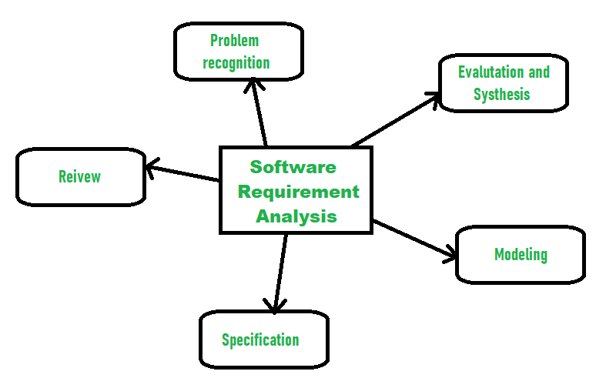

1. **Problem Recognition :**   
   The main aim of requirement analysis is to fully understand main objective of requirement that includes why it is needed, does it add value to product, will it be beneficial, does it increase quality of the project, does it will have any other effect. All these points are fully recognized in problem recognition so that requirements that are essential can be fulfilled to solve business problems.
2. **Evaluation and Synthesis :**   
   Evaluation means judgement about something whether it is worth(yogay) or not and synthesis means to create or form something. Here are some tasks are given that is important in the evaluation and synthesis of software requirement :
   * To define all functions of software that necessary.
   * To define all data objects that are present externally and are easily observable.
   * To evaluate that flow of data is worth or not.
   * To fully understand overall behavior of system that means overall working of system.
   * To identify and discover constraints that are designed.
   * To define and establish character of system interface to fully understand how system interacts with two or more components or with one another.
3. **Modeling :**   
   After complete gathering of information from above tasks, functional and behavioral models are established after checking function and behavior of system using a domain model that also known as the conceptual model.
4. **Specification :**   
   The [software requirement specification (SRS)](https://www.geeksforgeeks.org/software-requirement-specification-srs-format/) which means to specify the requirement whether it is functional or non-functional should be developed.
5. **Review :**   
   After developing the SRS, it must be reviewed to check whether it can be improved or not and must be refined to make it better and increase the quality.

## Software Requirements Specification (SRS):-

## A software requirements specification (SRS) is a document that describes what the software will do and how it will be expected to perform. It also describes the functionality the product needs to fulfill all stakeholders (business, users) needs.

### **Why Use an SRS Document?**

An SRS gives you a complete picture of your entire project. It provides a single source of truth that every team involved in development will follow. It is your plan of action and keeps all your teams — from development to maintenance — on the same page (no pun intended).

## UNIT:-2

## Basic Issues In Software Desing:-

## What Are The Basic Issues In Software Design?

Software production is an important area, but it can be difficult. There is no such thing as a finished product, and you can not find a software developer who has not made errors.

## Modularization.

## Coupling.

## Cohention

## Modularization:-

## Modularization is the process of dividing the software system into multiple independent module.

## Each Module Works independently.

## A module can be Used Many Times as their requirments. No need to write it again and again.

## Coupling:-

## Coupling is the measure of the degree of interdependence between the modules.

## A good software have low coupling.

## Type of coupling :-

## Content coupling.

## Common coupling.

## Control coupling.

## Stamp coupling.

## Data coupling.

## Cohention:-

## Cohention is a measure that define the degree of intra-dependability within elements of a module.

## It means “things” that belong together should be kept together.

## The greater the cohension, the better is the program design.

## TYPE Of Cohension:-

## Location Cohension

## Logical Cohension

## 

## Temporal Cohension

## 

## Procedural Cohension

## 

## Communication Cohension

## 

## Sequential Cohension

## 

# **Layering**

[Software engineering](https://www.geeksforgeeks.org/software-engineering-introduction-to-software-engineering/)is a fully layered technology, to develop software we need to go from one layer to another. All the layers are connected and each layer demands the fulfillment of the previous layer.

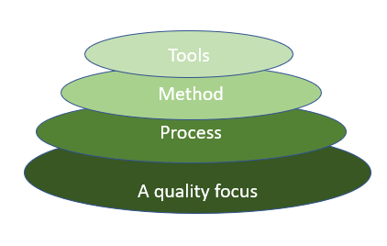

**1.** **A quality focus:**It defines the continuous process improvement principles of software. It provides integrity that means providing security to the software so that data can be accessed by only an authorized person, no outsider can access the data. It also focuses on maintainability and usability.

**2. Process:**It is the foundation or base layer of software engineering. It is key that binds all the layers together The software process covers all the activities, actions, and tasks required to be carried out for software development.

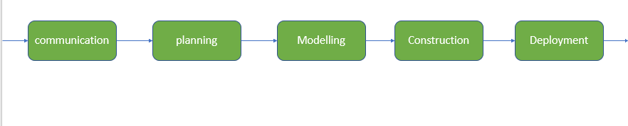

**3. Method:**During the process of software development the answers to all “how-to-do” questions are given by method. It has the information of all the tasks which includes communication, requirement analysis, design modeling, program construction, testing, and support.

**4.** **Tools:**Software engineering tools provide a self-operating system for processes and methods. Tools are integrated which means information created by one tool can be used by another.

* **Function Oriented Design:-**
* The design process for software systems often has two levels. At the first level the focus is on deciding which modules are needed for the system on the basis of SRS (Software Requirement Specification) and how the modules should be interconnected.
* **Function Oriented Design** is an approach to software design where the design is decomposed into a set of interacting units where each unit has a clearly defined function.
* **Generic Procedure:**  
  Start with a high level description of what the software / program does. Refine each part of the description one by one by specifying in greater details the functionality of each part. These points lead to Top-Down Structure.

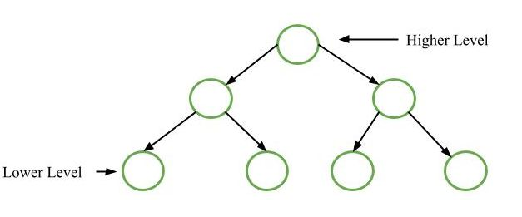

* **Function Oriented Design Strategies:**  
  Function Oriented Design Strategies are as follows:
* [Data Flow Diagram (DFD)](https://www.geeksforgeeks.org/levels-in-data-flow-diagrams-dfd/)**:**  
  A data flow diagram (DFD) maps out the flow of information for any process or system. It uses defined symbols like rectangles, circles and arrows, plus short text labels, to show data inputs, outputs, storage points and the routes between each destination.

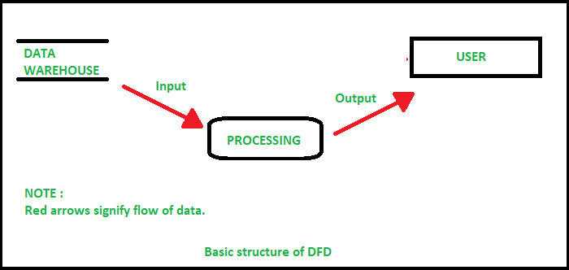

* **Data Dictionaries:**  
  Data dictionaries are simply repositories to store information about all data items defined in DFDs. At the requirement stage, data dictionaries contains data items. Data dictionaries include Name of the item, Aliases (Other names for items), Description / purpose, Related data items, Range of values, Data structure definition / form.

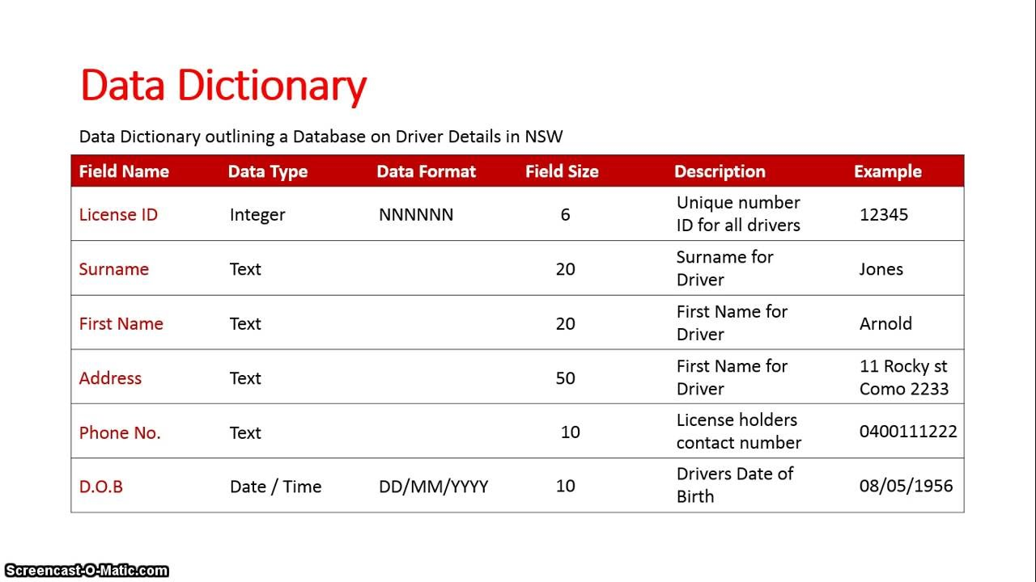

# **Structure Charts:-**

**Structure Chart** represent hierarchical structure of modules. It breaks down the entire system into lowest functional modules, describe functions and sub-functions of each module of a system to a greater detail. Structure Chart partitions the system into black boxes (functionality of the system is known to the users but inner details are unknown). Inputs are given to the black boxes and appropriate outputs are generated.

Modules at top level called modules at low level. Components are read from top to bottom and left to right. When a module calls another, it views the called module as black box, passing required parameters and receiving results.

**Symbols used in construction of structured chart**

1. **Module**  
   It represents the process or task of the system. It is of three types.
   * **Control Module**  
     A control module branches to more than one sub module.
   * **Sub Module**  
     Sub Module is a module which is the part (Child) of another module.
   * **Library Module**  
     Library Module are reusable and invokable from any module.

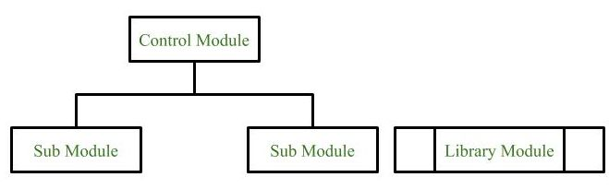

1. **Conditional Call**  
   It represents that control module can select any of the sub module on the basis of some condition.

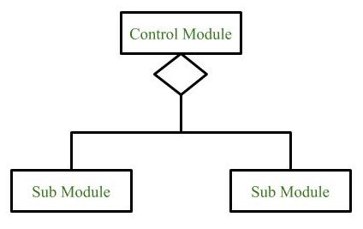

1. **Loop (Repetitive call of module)**  
   It represents the repetitive execution of module by the sub module.  
   A curved arrow represents loop in the module.

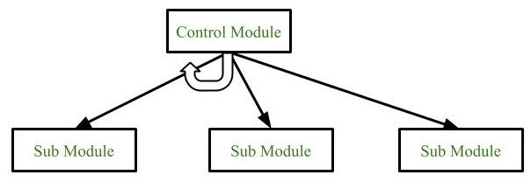

All the sub modules cover by the loop repeat execution of module.

1. **Data Flow**  
   It represents the flow of data between the modules. It is represented by directed arrow with empty circle at the end.

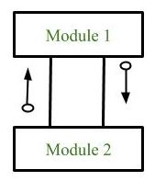

1. **Control Flow**  
   It represents the flow of control between the modules. It is represented by directed arrow with filled circle at the end.

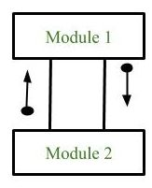

**Types of Structure Chart:**

1. **Transform Centered Structured:**  
   These type of structure chart are designed for the systems that receives an input which is transformed by a sequence of operations being carried out by one module.
2. **Transaction Centered Structure:**  
   These structure describes a system that processes a number of different types of transaction.

* **Object modelling:-**

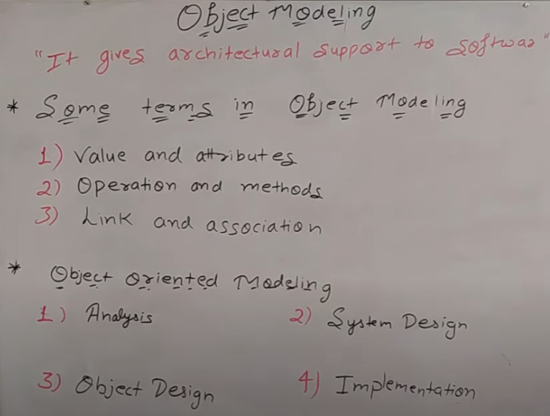

# **Unified Modeling Language (UML)**

**Unified Modeling Language (UML)** is a general purpose modelling language. The main aim of UML is to define a standard way to **visualize** the way a system has been designed. It is quite similar to blueprints used in other fields of engineering.

UML is **not a programming language**, it is rather a visual language. We use UML diagrams to portray the **behavior and structure** of a system. UML helps software engineers, businessmen and system architects with modelling, design and analysis.

**Do we really need UML?**

* Complex applications need collaboration and planning from multiple teams and hence require a clear and concise way to communicate amongst them.
* Businessmen do not understand code. So UML becomes essential to communicate with non programmers essential requirements, functionalities and processes of the system.
* A lot of time is saved down the line when teams are able to visualize processes, user interactions and static structure of the system.

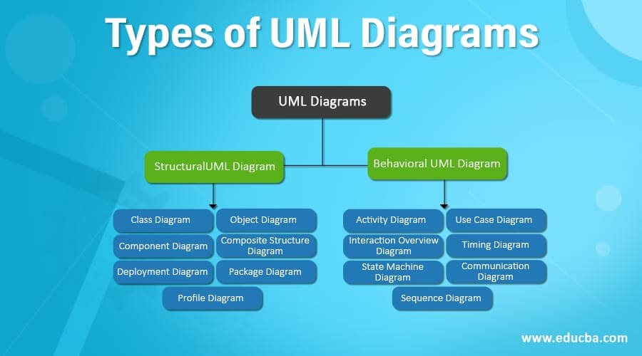

* **Object oriented software development:-**

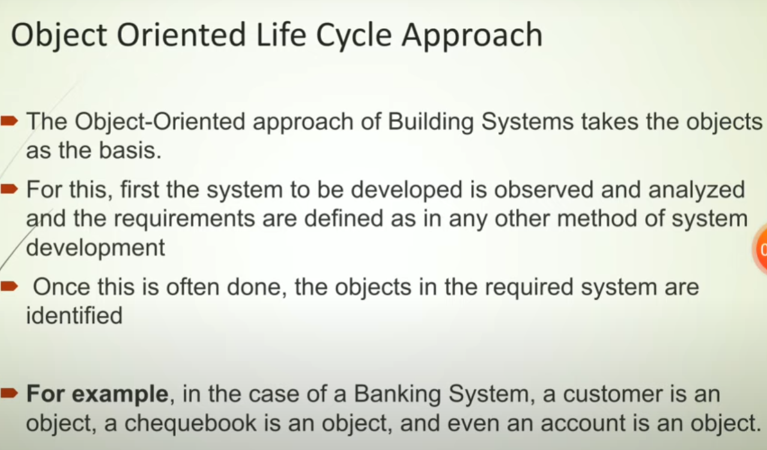

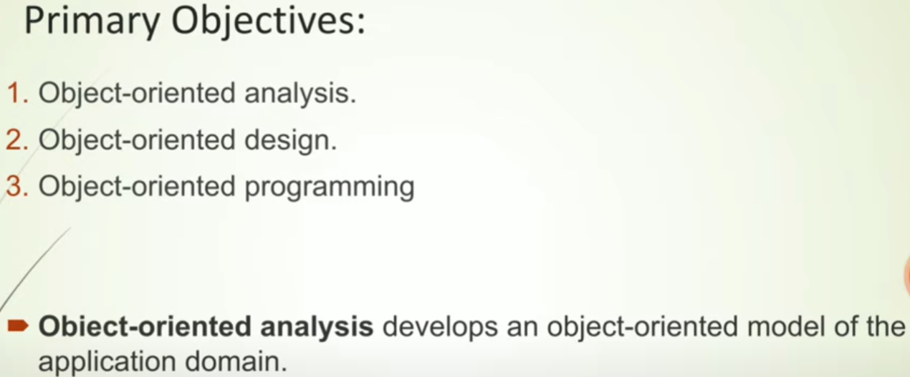

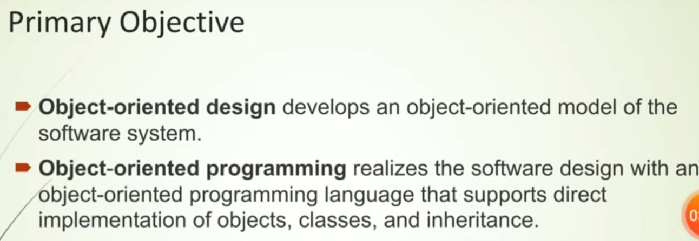

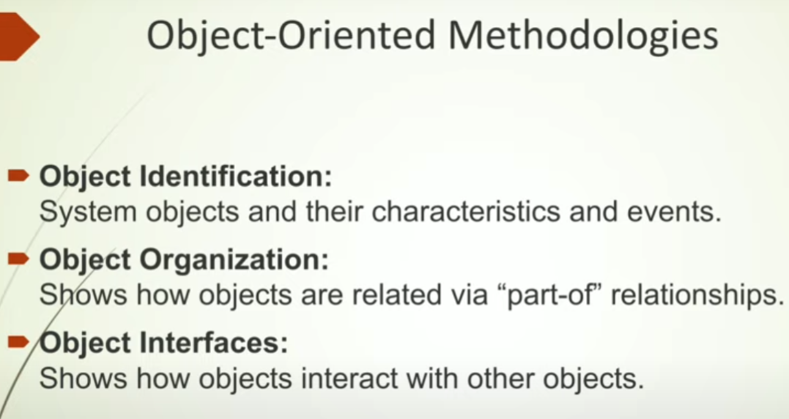

## Advantages and Disadvantages:-

## Advantages:-

## ****Improved software maintainability.****

## ****Faster development.****

## ****Lower cost of development.****

## ****Higher-quality software****

* **Disadvantages:-**
* **Larger program size.**
* **Slower programs.**
* **Not suitable for all types of problems.**

# **User Interface Design:-**

User interface is the front-end application view to which user interacts in order to use the software. The software becomes more popular if its user interface is:

* Attractive
* Simple to use
* Responsive in short time
* Clear to understand
* Consistent on all interface screens

There are two types of User Interface:

1. **Command Line Interface:** Command Line Interface provides a command prompt, where the user types the command and feeds to the system. The user needs to remember the syntax of the command and its use.
2. **Graphical User Interface:** Graphical User Interface provides the simple interactive interface to interact with the system. GUI can be a combination of both hardware and software. Using GUI, user interprets the software.

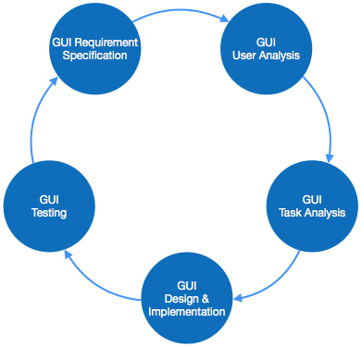 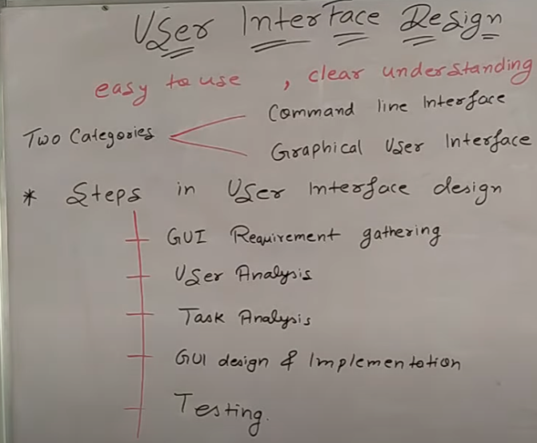

**coding standards and code review techniques:-**

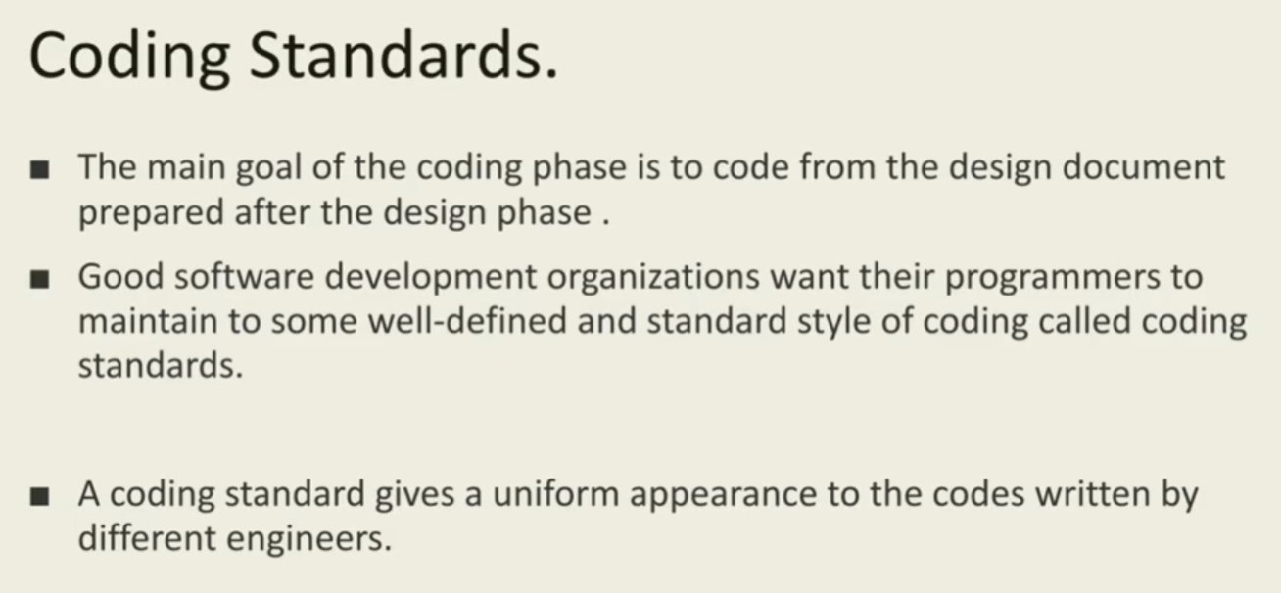

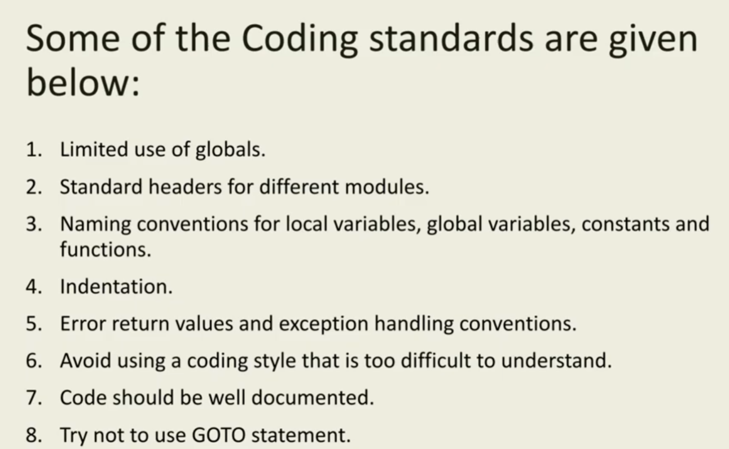

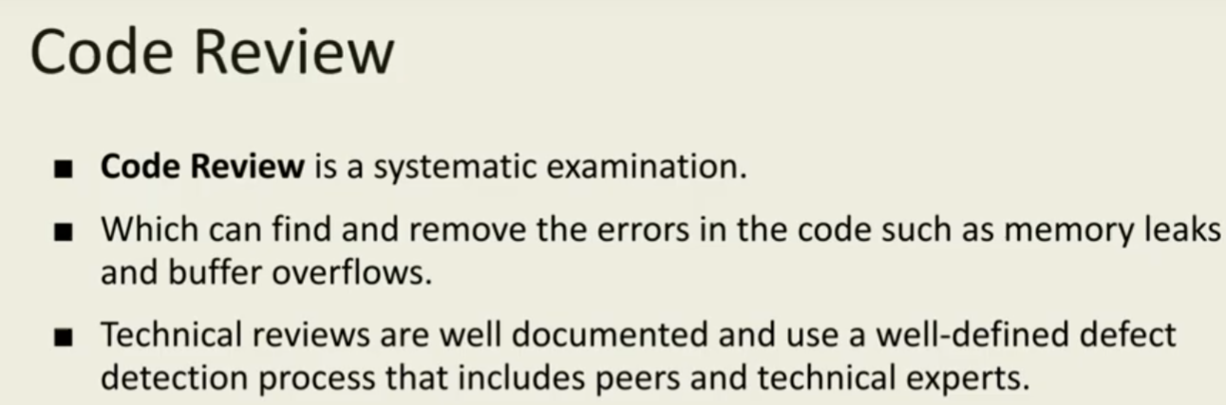

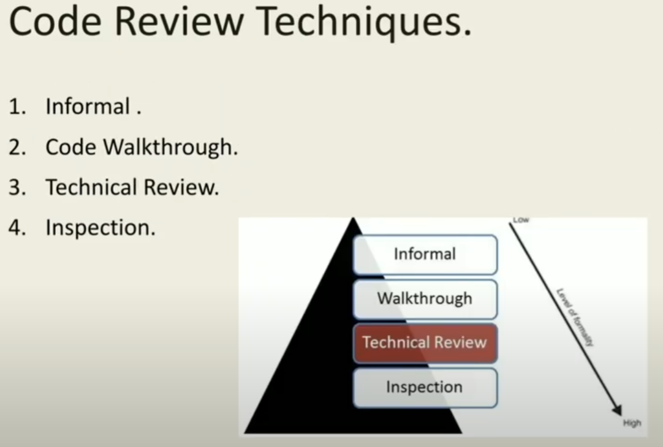

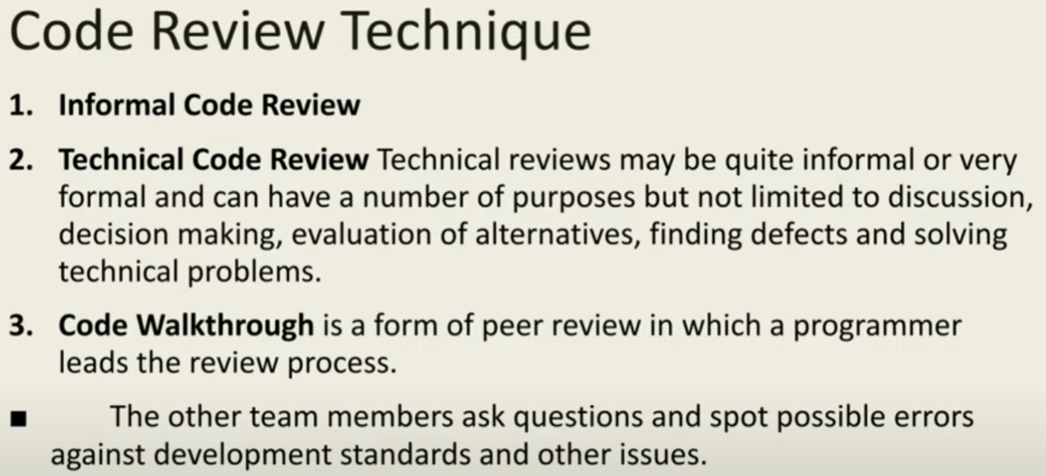

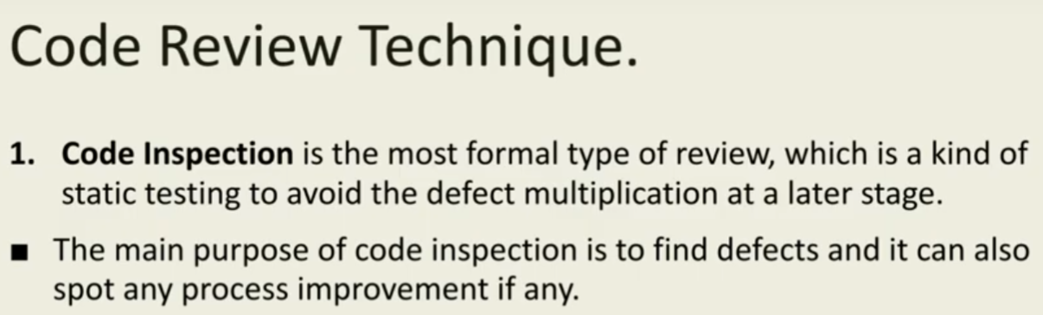

* **UNIT:-3**
* **Software Testing:-**

Software that does not work correctly can lead to many problems such as:

* Delay / Loss of time
* Futility / Loss of effort
* Wastage / Loss of money
* Shame / Loss of business reputation
* Injury or death

Testing helps in ensuring that software work correctly and reduces the risk of software failure, thereby avoiding the problems mentioned above.

* **Software Testing Goals:-**

The three main goals of Software Testing are:

* **Defect Detection:** Find defects / bugs in the software during all stages of its development (earlier, the better).
* **Defect Prevention:**As a consequence of defect detection, help anticipate and prevent defects from occurring at later stages of development or from recurring in the future.
* **User Satisfaction:**Ensure customers / users are satisfied that their requirements (explicit or implicit) are met.

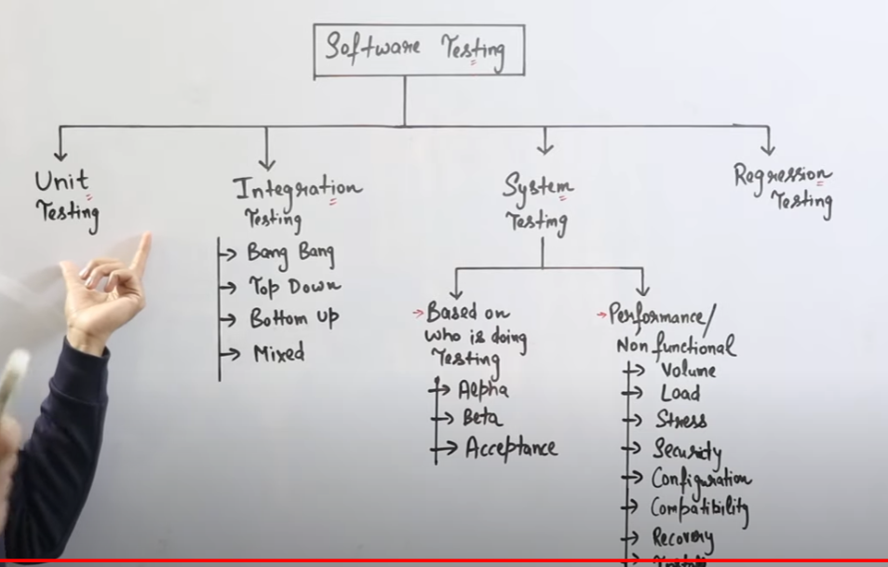

* **White-box testing** :-

**White-box testing** (also known as **clear box testing**, **glass box testing**, **transparent box testing**, and **structural testing**) is a method of [software testing](https://en.wikipedia.org/wiki/Software_testing) that tests internal structures or workings of an application, as opposed to its functionality (i.e. [black-box testing](https://en.wikipedia.org/wiki/Black-box_testing)). In white-box testing, an internal perspective of the system is used to design test cases.

White box testing test the application that how it is working. If you want to test the software and application than You must know about coding , data structure and other things.

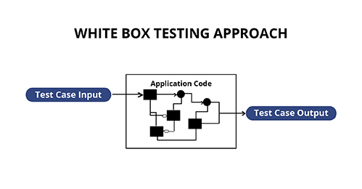

* **White-box test design techniques include the following**[**code coverage**](https://en.wikipedia.org/wiki/Code_coverage)**criteria:**
* [Control flow](https://en.wikipedia.org/wiki/Control_flow) testing
* Data flow testing
* Branch testing
* Statement coverage
* Decision coverage
* [Modified condition/decision coverage](https://en.wikipedia.org/wiki/Modified_condition/decision_coverage)
* Prime path testing
* Path testing

## Black Box Testing:-

**Black Box Testing** is a software testing method in which the functionalities of software applications are tested without having knowledge of internal code structure, implementation details and internal paths. Black Box Testing mainly focuses on input and output of software applications and it is entirely based on software requirements and specifications. It is also known as Behavioral Testing.

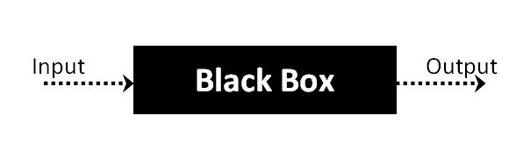

**Difference between white and black box testing**

|  |  |  |
| --- | --- | --- |
| S. No. | Black Box Testing | White Box Testing |
| 1. | It is a way of software testing in which the internal structure or the program or the code is hidden and nothing is known about it. | It is a way of testing the software in which the tester has knowledge about the internal structure or the code or the program of the software. |
| 2. | Implementation of code is not needed for black box testing. | Code implementation is necessary for white box testing. |
| 3. | It is mostly done by software testers. | It is mostly done by software developers. |
| 4. | No knowledge of implementation is needed. | Knowledge of implementation is required. |
| 5. | It is also called closed testing. | It is also called as clear box testing. |
| 6. | It is least time consuming. | It is most time consuming. |

## What exactly is test coverage:-

In software testing, test coverage is defined as a statistic that indicates the quantity of testing completed by a collection of tests. It will entail obtaining information about which sections of a program are executed when the test suite is performed in order to establish whether conditional statement branches have been taken.

It is a way for making sure that your tests are testing your code or how much of your code you exercised by running the test.

In test coverage tester test the codes of applications or software during developing time.

## Code Coverage and Test Coverage:-

Code coverage and test coverage are frequently mistaken. Even while the basic concepts are the same, they are not the same.

* Code Coverage refers to unit testing procedures that must target all parts of the code at least once and are performed by developers.
* Test Coverage, on the other hand, entails testing every requirement at least once and is clearly the responsibility of the QA team.
* **Test case design techniues:-**

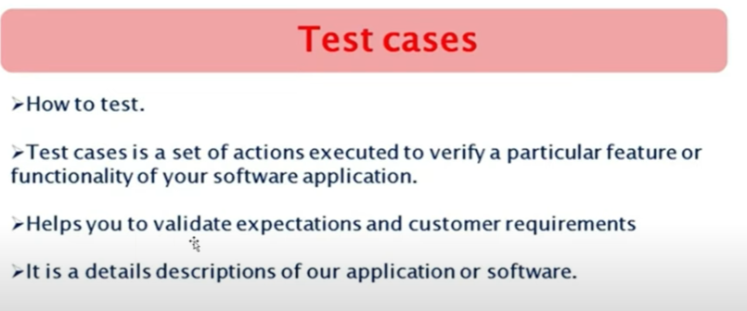

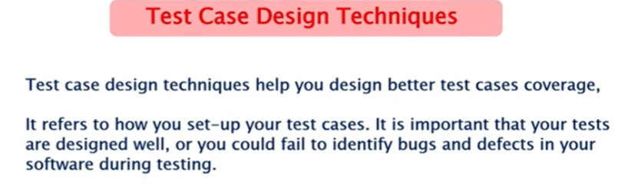

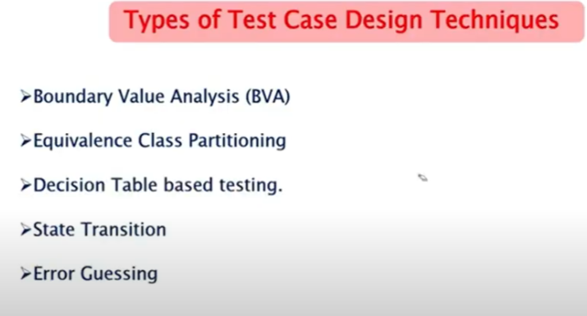

## Boundary Value Analysis (BVA)

Boundary value analysis is based on testing at the boundaries between partitions. It includes maximum, minimum, inside or outside boundaries, typical values and error values.

It is generally seen that a large number of errors occur at the boundaries of the defined input values rather than the center.

**Example:**

Input condition is valid between 1 to 10

Boundary values 0,1,2 and 9,10,11

## Equivalence Class Partitioning

Equivalent Class Partitioning allows you to divide set of test condition into a partition which should be considered the same. This software testing method divides the input domain of a program into classes of data from which test cases should be designed.

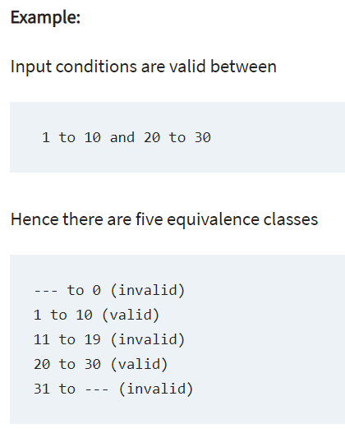

## Decision Table Based Testing

A decision table is also known as to Cause-Effect table. This software testing technique is used for functions which respond to a combination of inputs or events. For example, a submit button should be enabled if the user has entered all required fields.

## State Transition

In State Transition technique changes in input conditions change the state of the Application Under Test (AUT). This testing technique allows the tester to test the behavior of an AUT. The tester can perform this action by entering various input conditions in a sequence. In State transition technique, the testing team provides positive as well as negative input test values for evaluating the system behavior.

**Example:**

In the following example, if the user enters a valid password in any of the first three attempts the user will be able to log in successfully. If the user enters the invalid password in the first or second try, the user will be prompted to re-enter the password. When the user enters password incorrectly 3rd time, the action has taken, and the account will be blocked.

## State Transition Diagram

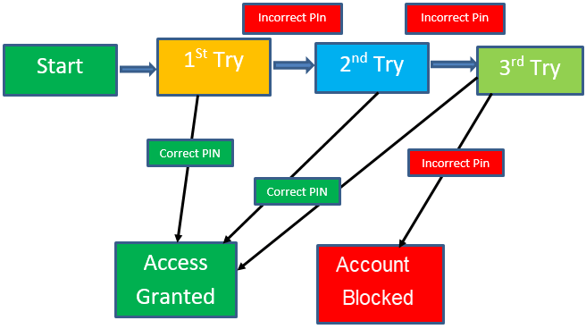

## Error Guessing

**Error Guessing** is a software testing technique based on guessing the error which can prevail in the code. The technique is heavily based on the experience where the test analysts use their experience to guess the problematic part of the testing application.

* **mutation testing:-**

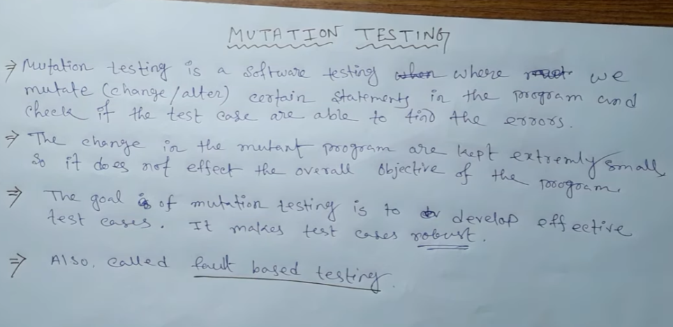

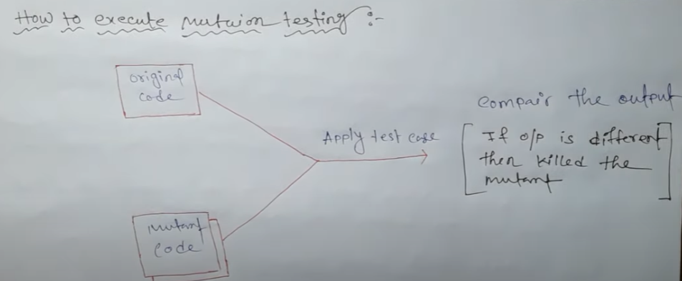

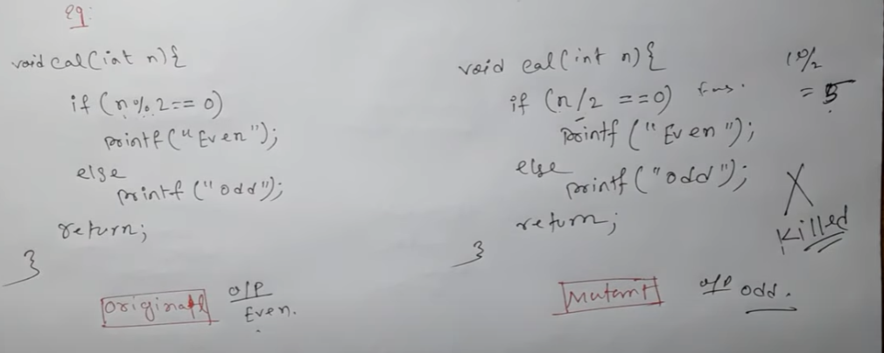

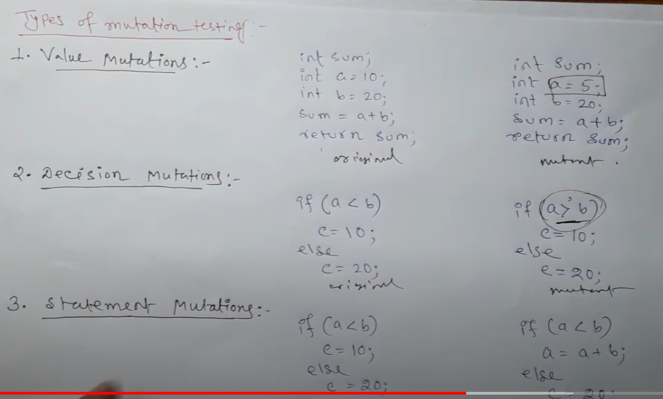

* + - **static and dynamic analysis:-**

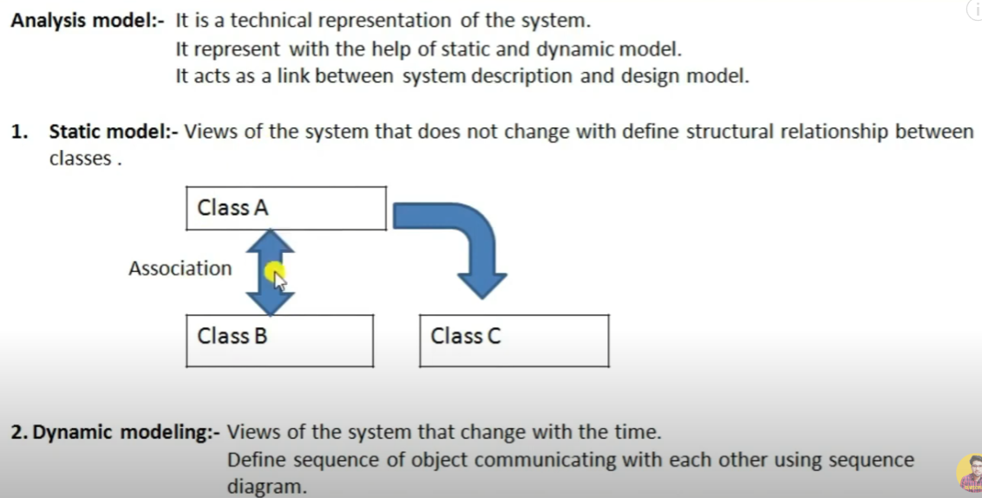

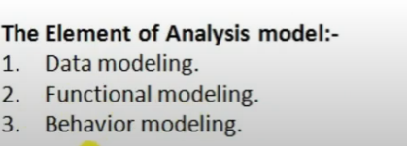

* **software reliability:-**

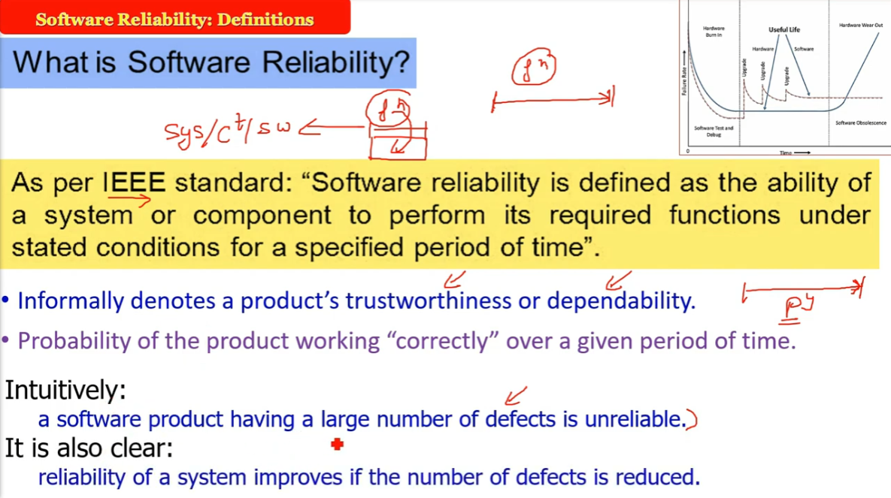

# **Reliability Growth Models:-**

The reliability growth group of models measures and predicts the improvement of reliability programs through the testing process. The growth model represents the reliability or failure rate of a system as a function of time or the number of test cases. Models included in this group are as following below.

1. **Coutinho Model –**  
   Coutinho adapted the Duane growth model to represent the software testing process. Coutinho plotted the cumulative number of deficiencies discovered and the number of correction actions made vs the cumulative testing weeks on log-log paper. Let N(t) denote the cumulative number of failures and let t be the total testing time

**2.Wall and Ferguson Model –**  
Wall and Ferguson proposed a model similar to the Weibull growth model for predicting the failure rate of software during testing. The cumulative number of failures at time t, m(t), can be expressed as

**UNIT-4:-**

**software project management:-**

# **What is Project?**

A project is a group of tasks that need to complete to reach a clear result. A project also defines as a set of inputs and outputs which are required to achieve a goal. Projects can vary from simple to difficult and can be operated by one person or a hundred.

Projects usually described and approved by a project manager or team executive. They go beyond their expectations and objects, and it's up to the team to handle logistics and complete the project on time. For good project development, some teams split the project into specific tasks so they can manage responsibility and utilize team strengths.

## What is software project management?

Software project management is an art and discipline of planning and supervising software projects. It is a sub-discipline of software project management in which software projects planned, implemented, monitored and controlled.

It is a procedure of managing, allocating and timing resources to develop computer software that fulfills requirements.

In software Project Management, the client and the developers need to know the length, period and cost of the project.

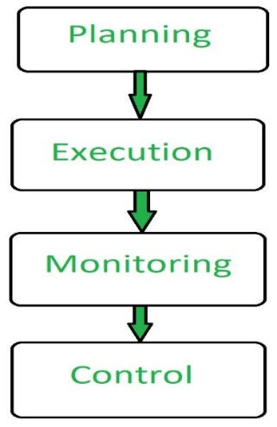

### **Prerequisite of software project management?**

There are three needs for software project management. These are:

1. Time
2. Cost
3. Quality

# **Software Project Planning:-**

A Software Project planning is the complete methodology of programming from requirement gathering to testing and support, completed by the execution procedures, in a specified period to achieve intended software product.

# **Project Monitoring and Control:-**

Monitoring and Controlling are processes needed to track, review, and regulate the progress and performance of the project. It also identifies any areas where changes to the project management method are required or not and initiates the required changes.

### **Cost Estimation:-**

A project can only come together with all the necessary materials and labor, and those materials and labors cost money. Putting together a budget that keeps costs to a minimum, while maximizing the project’s quality and scope can be challenging. This is why proper cost estimation is important.

Cost estimation in project management is the process of forecasting the financial and other resources needed to complete a project within a defined scope. Cost estimation accounts for each element required for the project—from materials to labor—and calculates a total amount that determines a project’s budget.

* **project sheduling using part and gantt chart:-**

PERT ([Program Evaluation & Review Technique](https://theconstructor.org/construction/pert-advantages-disadvantages-construction/14659/)) and Gantt charts are used in project management to represent the activities or tasks in a project from start to end. They allow us to visualize the workflow and the project plan. The main difference between PERT and Gantt charts is that they use different methods to present the project data.

The table below enlists the significant differences between PERT and Gantt Charts.

## Difference between PERT & Gantt Charts

|  |  |
| --- | --- |
| **Gantt Charts** | **PERT Network** |
| * A Gantt chart is a bar chart used to illustrate the individual tasks associated with the project from start to end. | * PERT chart is a flow chart or network diagram which illustrates the project tasks along with their interdependencies. |
| * Gantt Chart was developed by Henry Gantt around the years 1910 to 1915. | * The United States Navy introduced a PERT chart or PERT network diagram in the 1950s. |
| * Used for more small, common and repetitive projects | * Used for large, complex and non-repetitive projects. |
| * Easy to read the work progress. | * complexity to read the work progress. |
|  |  |

* **CPM(CRITICAL PATH METHOD)**

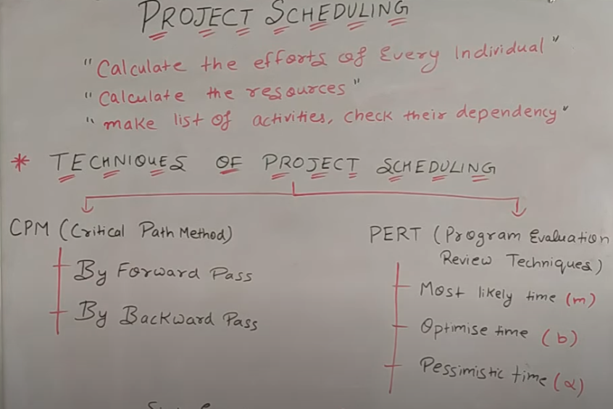

* **BY FORWADING PASS TELLS THAT WHEN YOUR PROJECT HAD FINISED.**
* **BY BACKWARD PASS TELLS THAT WHEN YOUR PROJECT HAD STARTED.**
* **Rayleigh-norden result:-**

The Lawrence Putnam model describes the time and effort requires finishing a software project of a specified size. Putnam makes a use of a so-called The Norden/Rayleigh Curve to estimate project effort, schedule & defect rate as shown in fig:

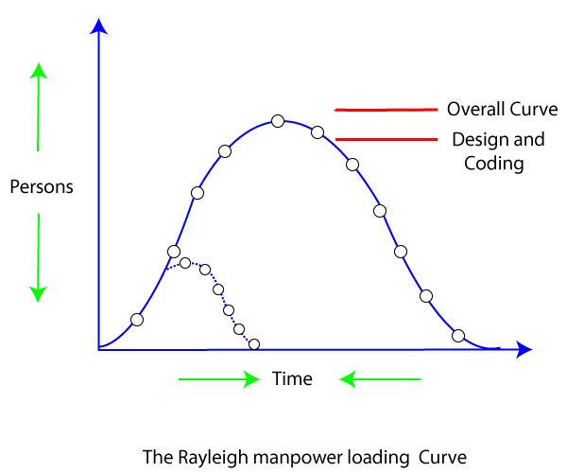

Putnam noticed that software staffing profiles followed the well known Rayleigh distribution. Putnam used his observation about productivity levels to derive the software equation:

## Software Quality:-

Software Quality is the degree to which the correct software produced. Quality software is reasonably bug or defects free, delivered on time and within budget, meets requirements, expectations, and maintainable. Standard ISO 8402-1986 defines quality as “the totality of characteristics and features of a product or service that bears its ability to implied needs or Satisfy stated.” In the original view, quality is hard to describe but can be recognized if it is present.

A process to check the system accepts the requirements of a user or not. Click to explore about, [User Acceptance Testing](https://www.xenonstack.com/insights/what-is-user-acceptance-testing)

* In the user view, quality is fitness for purpose or meeting user’s needs.
* In the manufacturing view, quality means conformance to process standards.

Key aspects of quality for the customer are -

* Good design – looks and feel
* Durable – lasts as long as
* Consistency
* Reliable – acceptable level of breakdowns/failure
* Good functionality
* Good after sales service
* Value for money

**UNIT-5**

* **ISO:-**

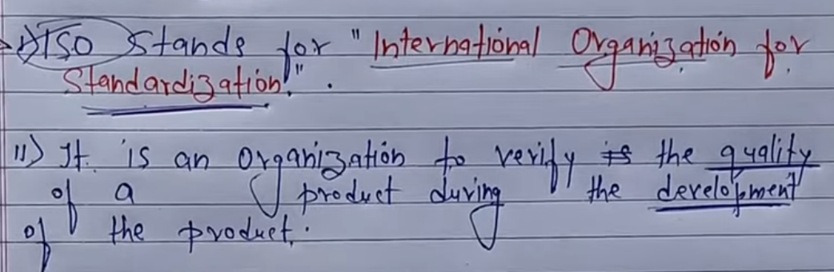

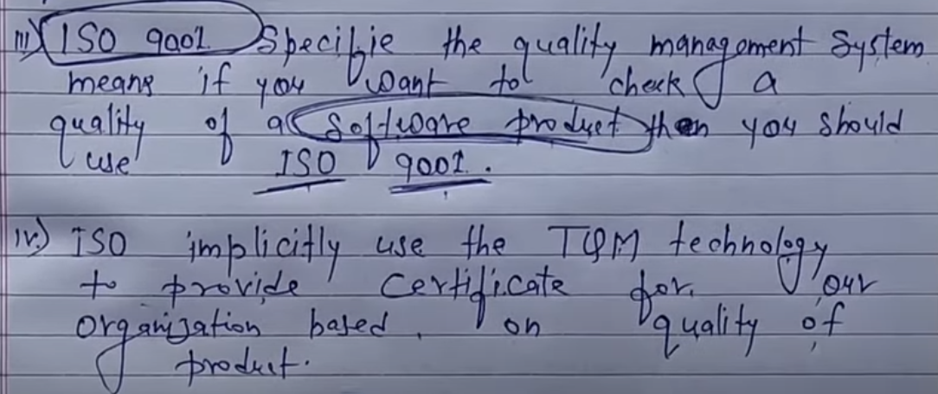

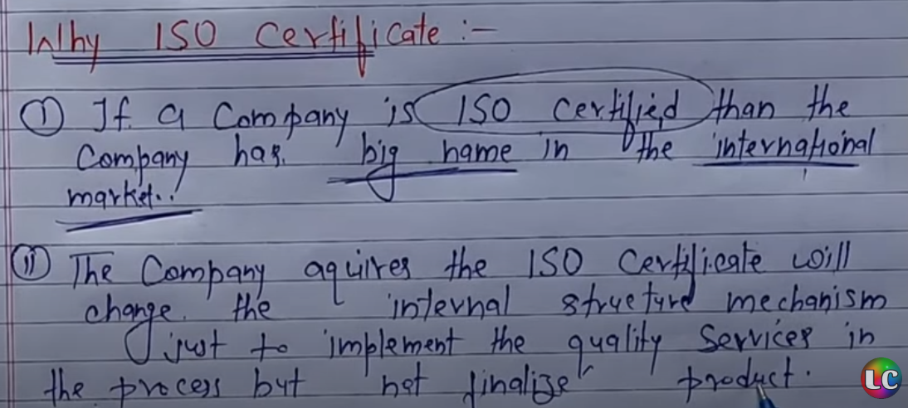

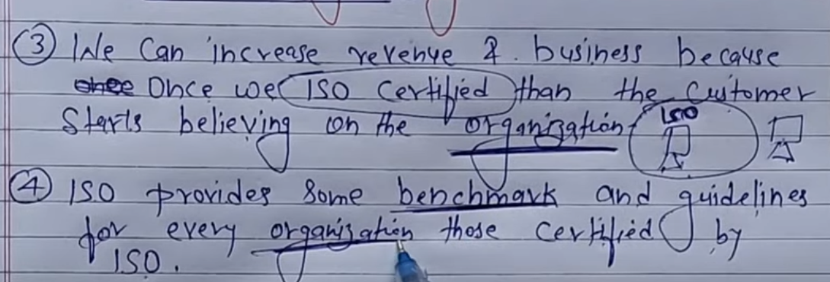

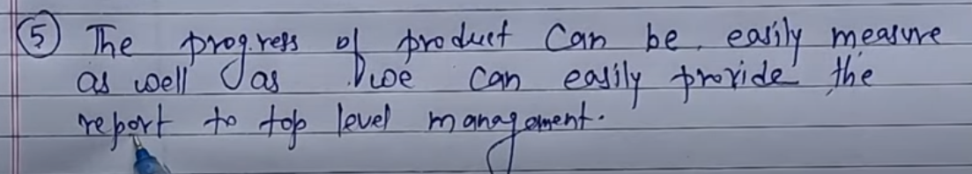

# **Software Engineering Institute Capability Maturity Model (SEICMM):-**

**It is process to increasing IT company level**

The Capability Maturity Model (CMM) is a procedure used to develop and refine an organization's software development process.

The model defines a five-level evolutionary stage of increasingly organized and consistently more mature processes.

CMM was developed and is promoted by the Software Engineering Institute (SEI), a research and development center promote by the U.S. Department of Defense (DOD).

Capability Maturity Model is used as a benchmark to measure the maturity of an organization's software process.

## Methods of SEICMM

There are two methods of SEICMM:

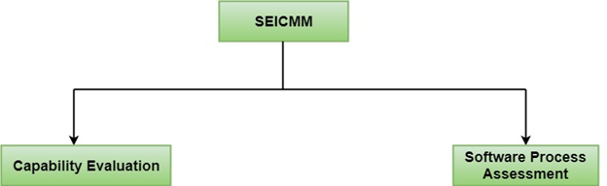

**Capability Evaluation:** Capability evaluation provides a way to assess the software process capability of an organization. The results of capability evaluation indicate the likely contractor performance if the contractor is awarded a work. Therefore, the results of the software process capability assessment can be used to select a contractor.

**Software Process Assessment:** Software process assessment is used by an organization to improve its process capability. Thus, this type of evaluation is for purely internal use.

SEI CMM categorized software development industries into the following five maturity levels. The various levels of SEI CMM have been designed so that it is easy for an organization to build its quality system starting from scratch slowly.

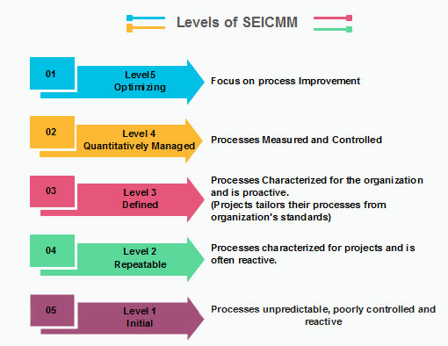

* **DIFFERENT BETWEEN ISO AND SEI-CMM:-**

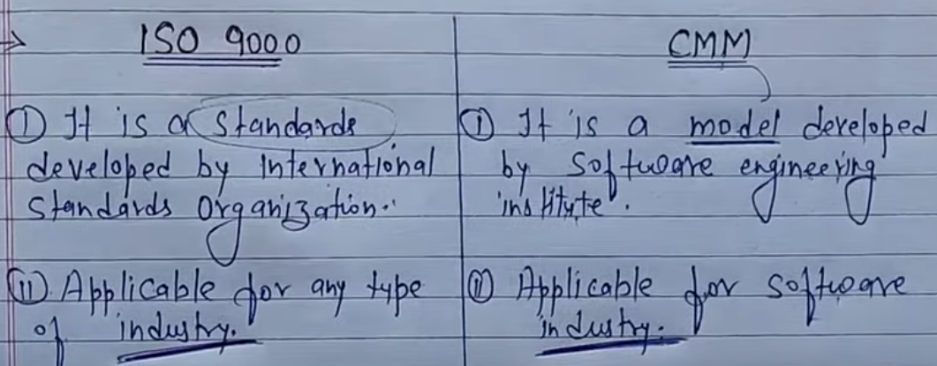

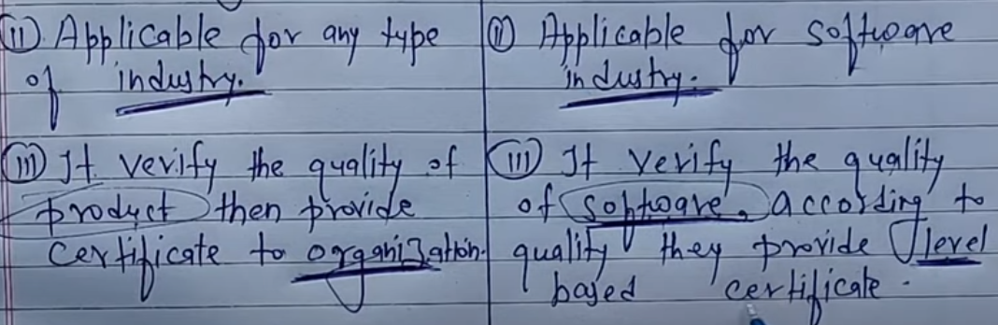

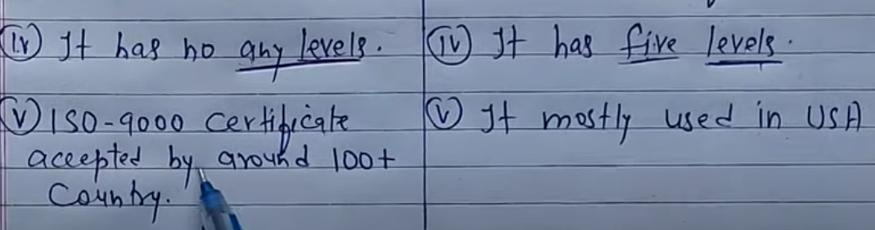

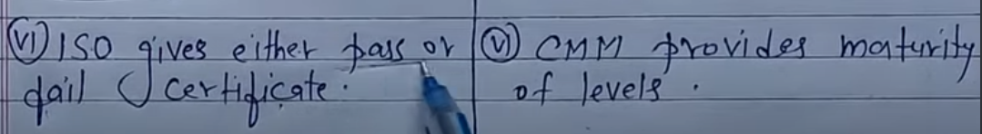

* **PAP:-**

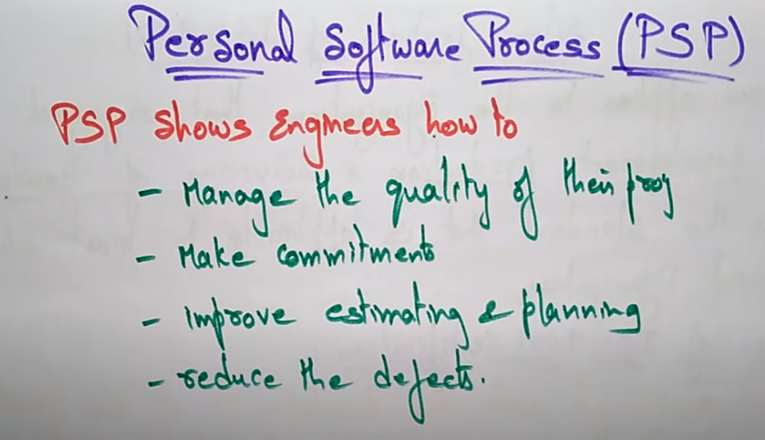

* **SIX SIGMA:-**

Six Sigma is the process of improving the quality of the output by identifying and eliminating the cause of defects and reduce variability in manufacturing and business processes.

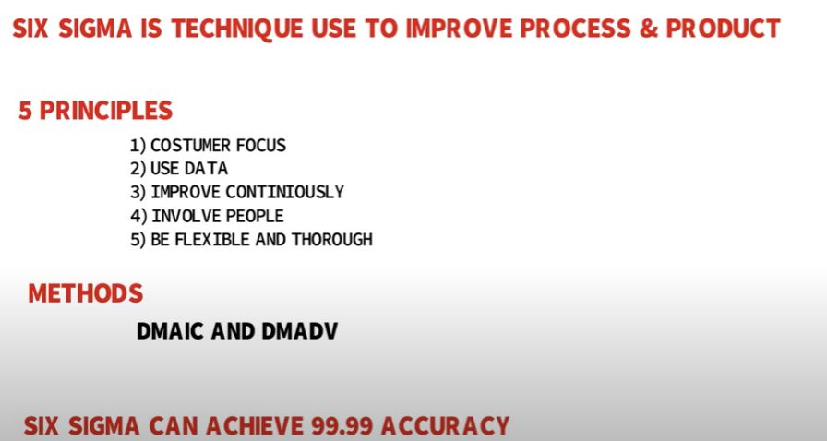

* **Computer aided software engineering(CASE):-**

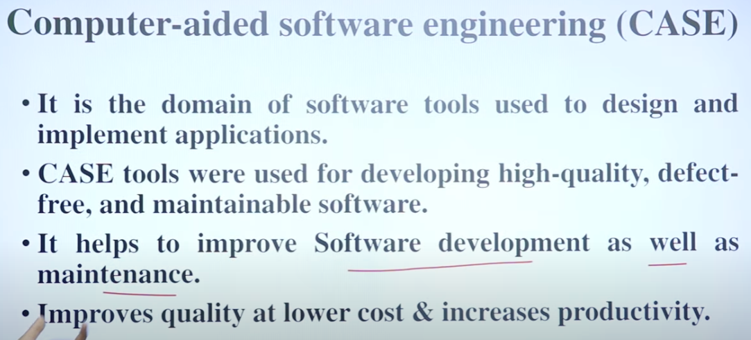

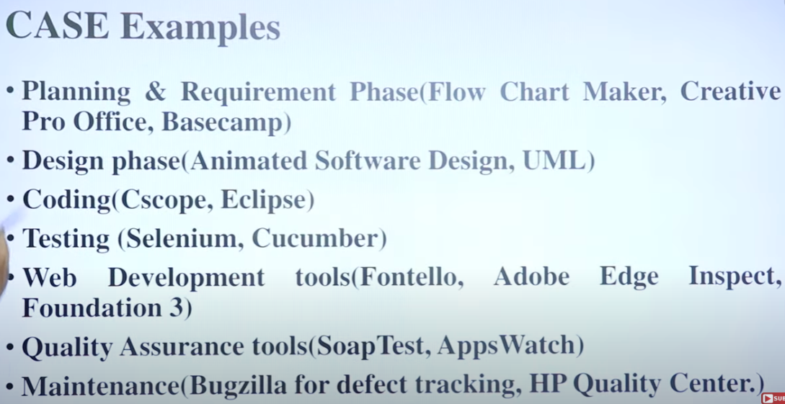

**SOFTWARE MAINTENANCES:-**

Software Maintenance is the process of modifying a software product after it has been delivered to the customer. The main purpose of software maintenance is to modify and update software applications after delivery to correct faults and to improve performance.

Software maintenance is also an important part of the Software Development Life Cycle(SDLC). To update the software application and do all modifications in software application so as to improve performance is the main focus of software maintenance.

**Need for Maintenance –**   
Software Maintenance must be performed in order to:

* Correct faults.
* Improve the design.
* Implement enhancements.
* Interface with other systems.
* Retire software.
* Requirement of user changes.
* Run the code fast

## software reuse:-

Software reuse is a term used for developing the software by using the existing software components. Some of the components that can be reuse are as follows;

* Source code
* Design and interfaces
* User manuals
* Software Documentation
* [Software requirement specifications](https://t4tutorials.com/srs-software-requirement-specification/) and many more.

## ****advantages of software reuse:-****

* **Less effort:** Software reuse requires less effort because many components use in the system are ready made components.
* **Time-saving:** Re-using the ready made components is time saving for the software team.
* **Reduce cost:** Less effort, and time saving leads to the overall cost reduction.
* **Increase software productivity:**when you are provided with ready made components, then you can focus on the new components that are not available just like ready made components.
* **component based software development:-**

COMPONENT BASED SOFTWARE IS TECHNIC TO DEVLOP THE SOFTWARE HELF OF COMPONENTS .

COMPONENTS MEANS WHICH HAS ALREADY CREATED LIKE :- calendar , payment method These component are already in market only we can use in our software by buying or asking with that software owner.